Network Topology when network is not in use:

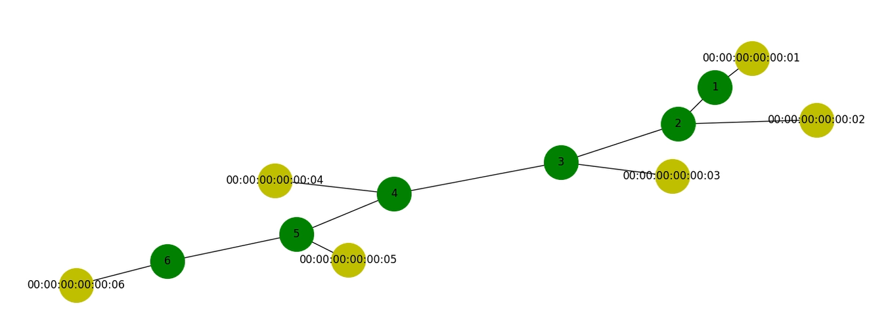

Network Topology under load (h1 to h2):

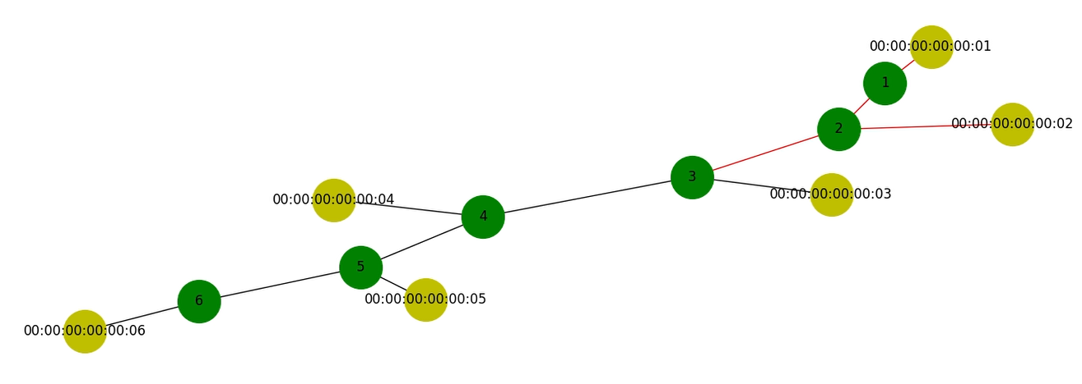

Network Topology under load (h1 to h6):

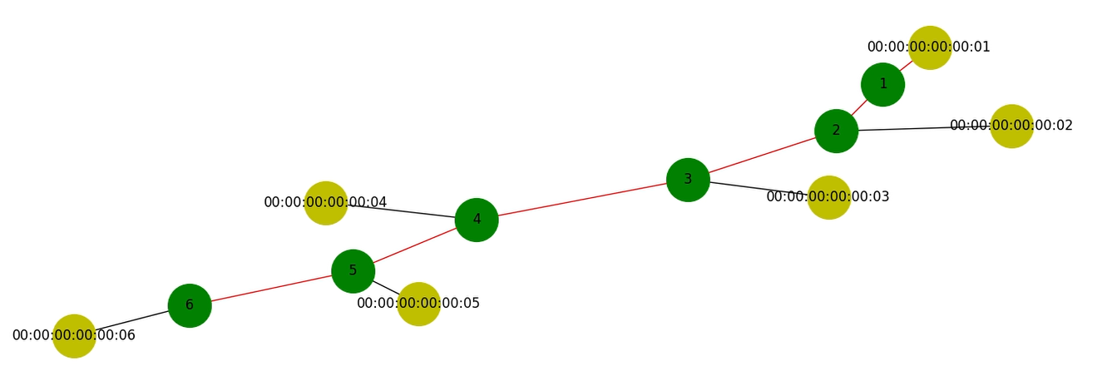

We have also attached the modified ryu controller and the topology that we are using.

To create the topology:

sudo mn --mac --controller=remote --custom ./ring.py --topo Ring --link tc,bw=0.1

To launch ryu:

sudo ryu-manager ./ryu_networkx_group.py --observe-links

As seen from above topology we have disabled the link between s1 and s6 as the ryu.topology.api needed to get all links, switches and host is not working with the ryu STP controller library.